Finding Newspaper Articles

The UDM Library has several subscription databases with full text newspaper articles.

- Go to the library portal at http://research.udmercy.edu/ and click on the “Articles, Journals + Databaes” tab in center of the page.
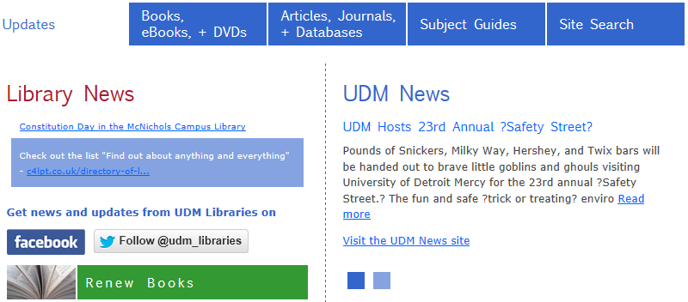

- Click on “ALL” to see an alphabetical list of all the databases.
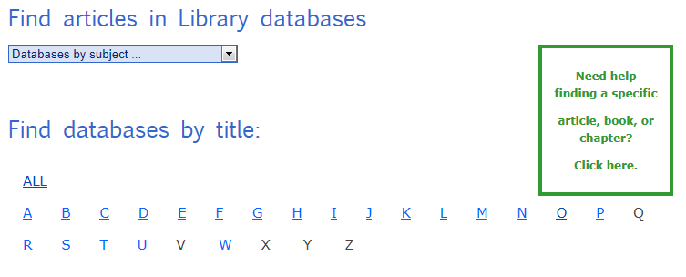

For local newspapers, scroll down to the Michigan Newspapers database. It includes the Detroit News and other local papers.

- Scroll down and click on the “Michigan Newspapers” link

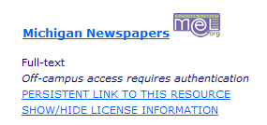

- Scroll down and click on "Michigan".
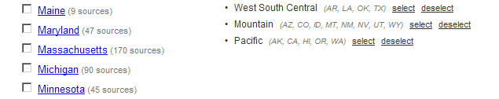

- Note that newswires and magazines are also included in this database. Dates covered are also included.

- If you want to browse through an issue of a newspaper, click on the link for its title.
- Scroll down and click on the link for the Detroit News.
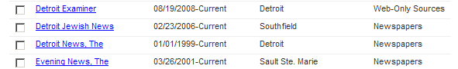

- Note that on the lower left hand side of the page, you can browse single issues.
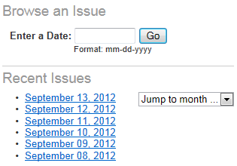

- If you want to search for articles on a specific topic, click on the checkboxes of one or more newspapers and enter your terms in the search boxes at the top of the page.

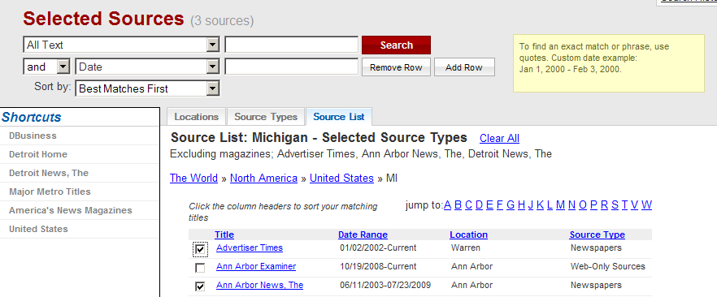
For International and National newspapers, try InfoTrac Newsstand. It includes many foreign newspapers as well as USA Today and the Christian Science Monitor.

- Go back to the library portal at http://research.udmercy.edu/ and click on the “Articles, Journasl + Databases” tab in center of the page.

- Click on the letter "I"

- Scroll down and click on the link for “InfoTrac Newsstand”.

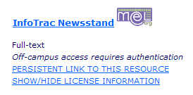

- Click on the Advanced Search tab in the orange line near the top of the page.

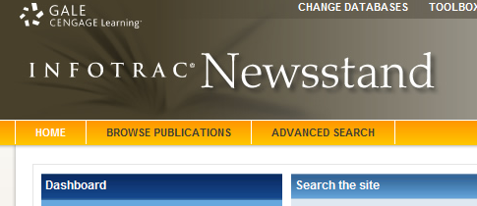

- If are looking for articles in a specific newspaper, search by “Publication Title”.
  - Search for articles in USA Today

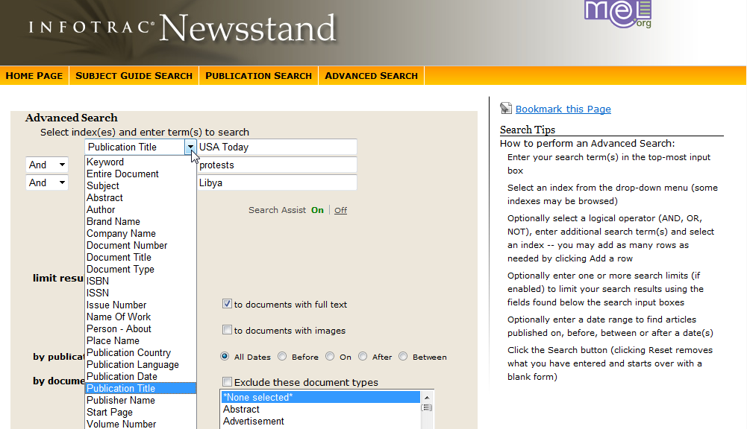

- To search for articles in foreign newspapers, change the Boolean term in the small box next to a search box to “Not” and type “United States” into the search box.

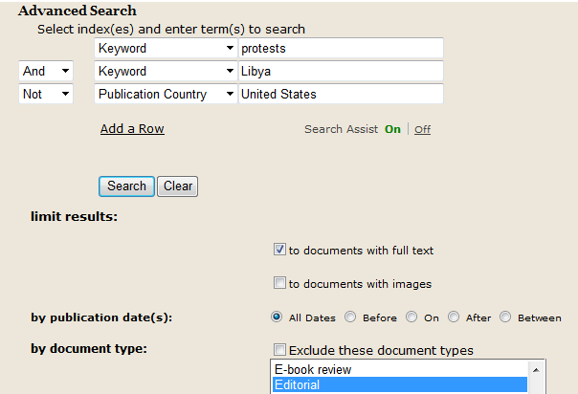

- Note that you can also limit your search by Document type

The UDM library also subscribes to a database that includes full text articles from the New York Times.

- To search for articles on a particular topic, search the “New York Times (Gale)” database. (Go back to the library webpage, click on the "Articles, Journals + Databases" tab, click on the letter “N”, and scroll down to the correct link).



