Finding Journal and Magazine Articles

- To search for journal articles, go to the library website at http://research.udmercy.edu.

- The UDM libraries subscribe to many databases with full-text articles from magazines, newspapers, and professional journals. Some databases are multidisciplinary, with articles in many different fields, while others are subject-specific. .

- Click on the "Articles, Journals + Databases" tab in the middle of the page.
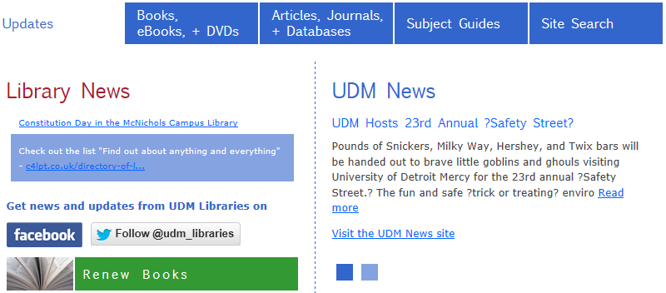

- Click on the dropdown box to see discipline-specific databases. For example, to search for:
  - Effects of different types of music on surgeons and patients in the operating room, look in a medical or nursing database.
  - Effects of different types of music played during study periods on students' ability to retain science facts, look in an education database.
  - What is known about ancient Roman music, look in a history database.
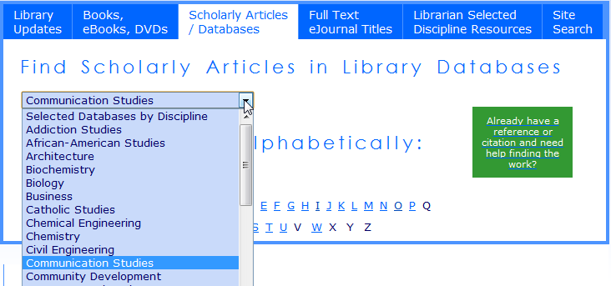
- When you're first starting your research, you may want to begin with a general database such as "Academic OneFile" or “OmniFile Full Text ". Instead of clicking on the dropdown box, click on the letter "A".

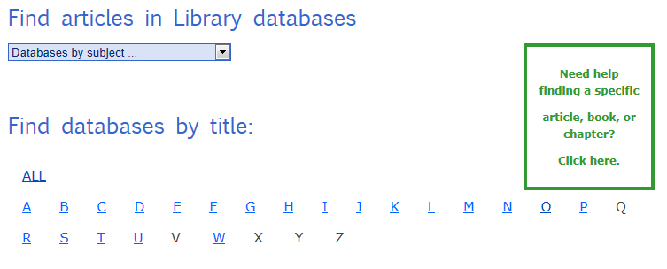

- Scroll down and click on the "Academic OneFile" link.

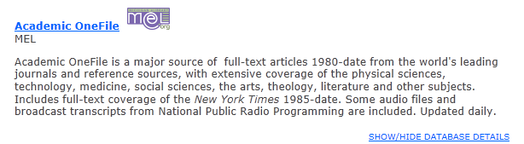

- If you are off-campus, you will be asked for to sign with your TitanConnect username and password.

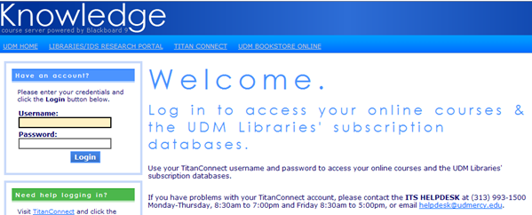

- Click on the Advanced Search tab in the orange bar near the top of the page.



- Try a search for "meningitis" and “college students”.

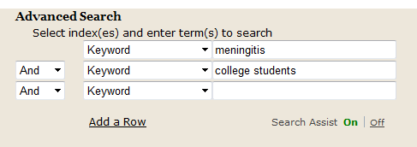

- In the left hand frame, note the content types. Articles in academic journals may be scholarly.

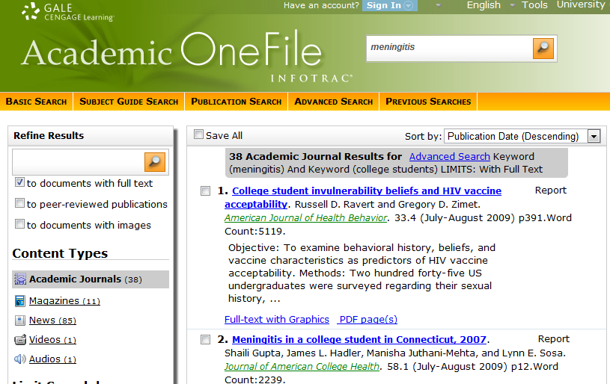
- Click on an article title to see the full article.

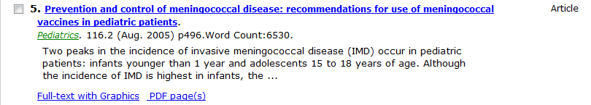

- On the right hand side you’ll see a “Tools” box. Click on the “Citation tools” icon.

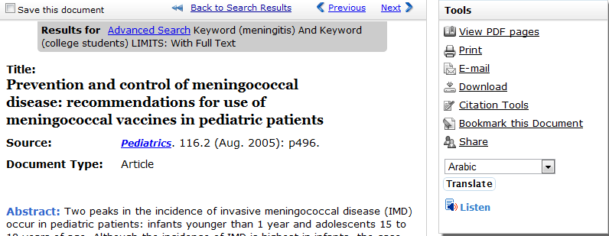

- Choose the citation format you need and then click on the save button.

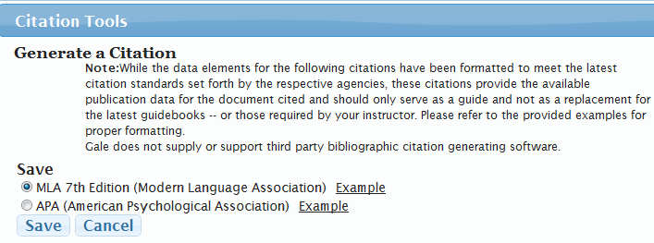

- You can cut and paste the citation into your paper or assignment.

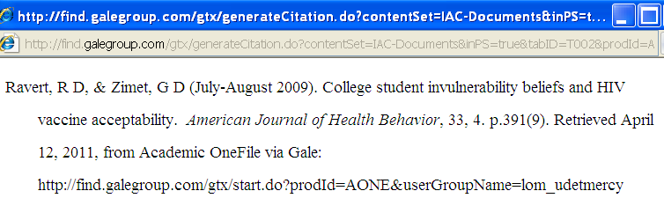

***TEACH ACT***

(Click on “Library Information & Policies” link in the blue left frame, then scroll to the very bottom of the page)

http://research.udmercy.edu/libraryservices/info_standards.php?id=123

- Applies to copyrighted materials used within Knowledge (Blackboard) courses.
- Students are to be reminded not to pass this content on to others outside their course.
- Students shall be reminded that “no further copies” will be made of retained copies of digital transmissions that include copyrighted materials.

