Finding Full-Text Articles Online

- If you need a specific journal or magazine article, the UDM library may have the full text in an online subscription database.

- To search for an article online:
  - Go to the re:search portal at http://research.udmercy.edu
  - Click on the “Articles, Journals + Databases" tab in the center of the page.

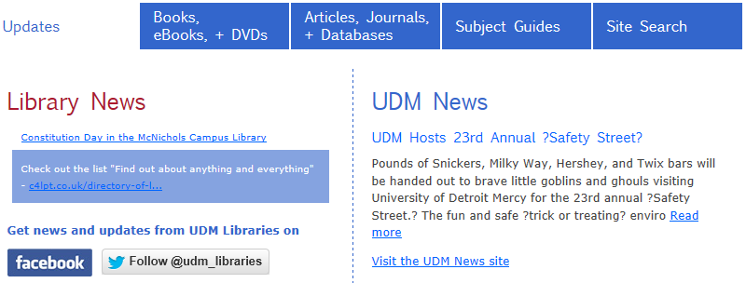

  - Scroll down on the page until you see the heading that says “Find online journals by title”. Underneath it is a search box.

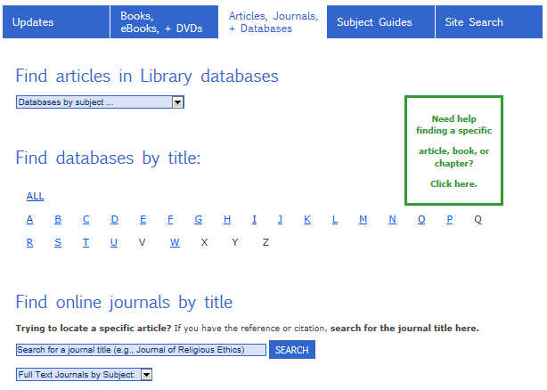

  - Search for the name of the journal or magazine (not the title of the article). For example, look for Argumentation and Advocacy to see if we have the full text available for the following citation:

Hess, Aaron. "Democracy through the polarized lens of the camcorder: argumentation and vernacular spectacle on YouTube in the 2008 election." Argumentation and Advocacy 47.2 (2010): 106+.

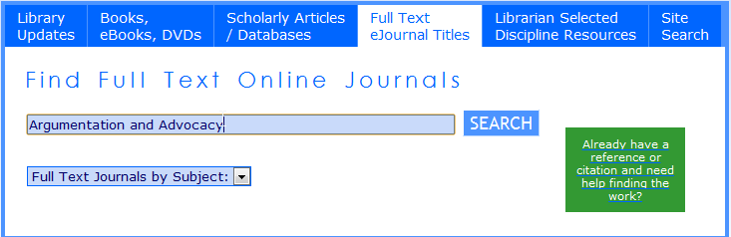

  - If the title is listed, you should be able to click directly on any database in the search results that includes the date you need.***

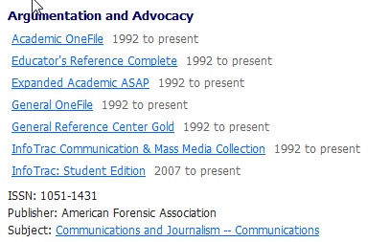

  - In the database, you will probably go to the journal’s page. Look for a listing or dropdown box with issues or dates.

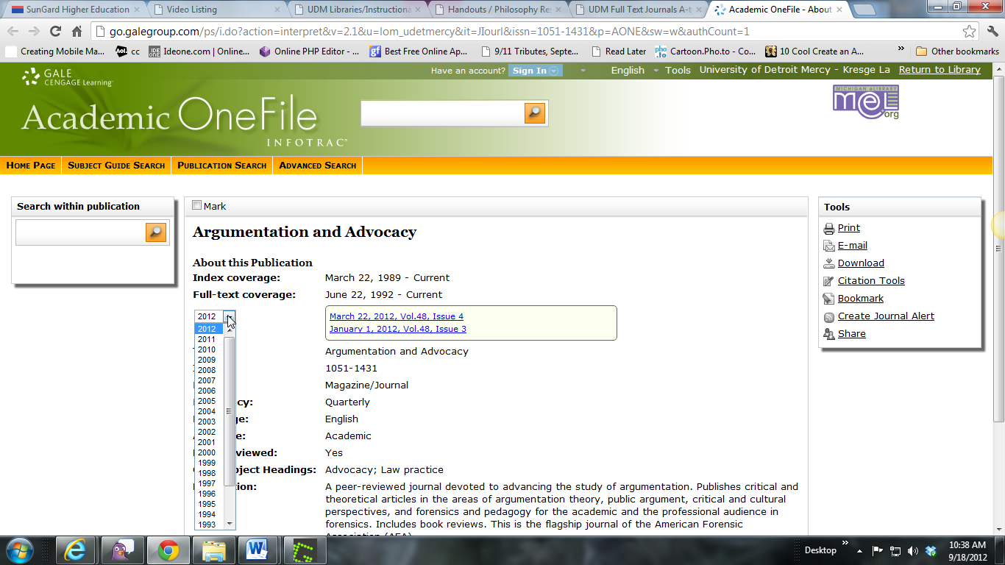

  - Click on the year that your article was published.

Hess, Aaron. "Democracy through the polarized lens of the camcorder: argumentation and vernacular spectacle on YouTube in the 2008 election." Argumentation and Advocacy 47.2 (2010): 106+.

  - Click on the volume and issue.

Hess, Aaron. "Democracy through the polarized lens of the camcorder: argumentation and vernacular spectacle on YouTube in the 2008 election." Argumentation and Advocacy 47.2 (2010): 106+.

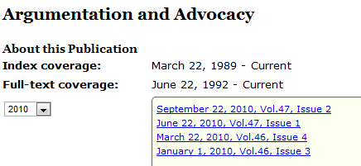

  - Scroll down the list of articles to find the article you need. Click on the Full-text or PDF page(s) link to see the full article.

Hess, Aaron. "Democracy through the polarized lens of the camcorder: argumentation and vernacular spectacle on YouTube in the 2008 election." Argumentation and Advocacy 47.2 (2010): 106+.

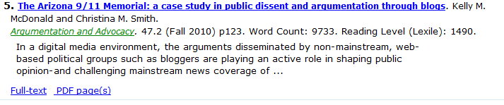

*** If a database link does not work, try going into the database from our alphabetical database listing:

    - Go back to the library research portal at http://research.udmercy.edu.
    - Click on the “Articles, Journals + Databases" tab in the center.
    - Click on the first letter of the database name (e.g. “A” for Academic OneFile)

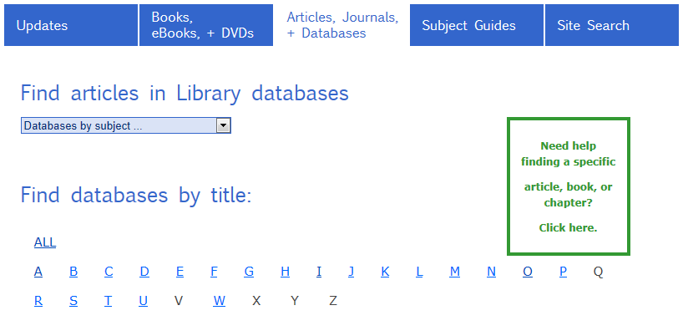

    - Then click on the database name…

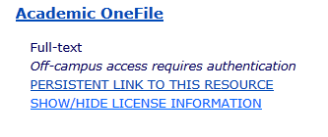

    - and search for the article by author or article name.



